Dealing with Risk/Uncertainty

Example: Furrow vs. Drip Irrigation Systems
common 5-year analysis period (= physical life & ESL of drip system)
g, annual increase in water costs (in constant $) due to rising demand
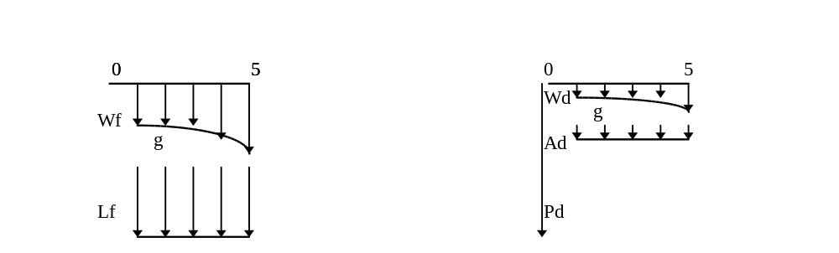
A) Furrow
W_{f}, first year annual cost for water, constant $/acre (all other costs on same basis)
L_{f}, possible annual loss if water allocation is reduced because of drought

PW_{f} = -L_{f} (P/A,i’,5) - W_{f} (P/A₁,g,i’,5)

B) Drip
P_{d}, purchase price for drip system: pipe, drip lines, emitters
A_{d}, additional annual cost for drip system: labor, maintenance
W_{d}, first year annual cost for water

PW_{d} = -P_{d} - A_{d} (P/A,i’,5) - W_{d} (P/A₁,g,i’,5)

I. Use “most likely” estimates (ignore uncertainty)

Variable | Most Likely Est
Lf | 200
Wf | 100
Pd | 1000
Ad | 25
Wd | 25
i' | 0.1
g | 0.05
PWf = -1173./acre
PW_{d} = -1199./acre

But how certain are the estimates?
In order of increasing uncertainty: P_{d}, W_{f}, W_{d}, A_{d}, i’, g, L_{f}
For simplicity, assume only g and L_{f} are uncertain, assign possible ranges.

Want ranges to cover all the possible results, don’t set them too narrow!!!
Variable | Min | Max
Lf | 0 | 500
g | 0 | 0.1

II. Sensitivity Analysis

See how sensitive the choice of best alternative (of a set of M.E. alts) is to the uncertainty

(change only one variable at a time, hold others at “most likely” ests)

a) hold L_{f} = 200, plot both PWs over the range of g (suggest five data points)

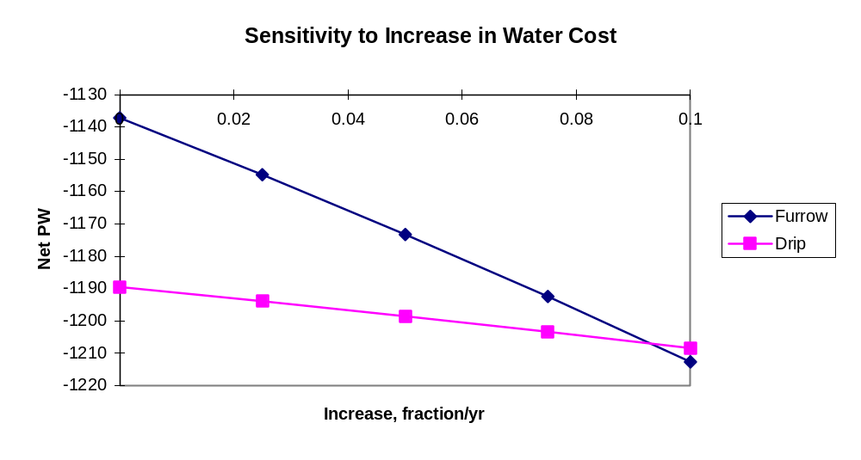
Regret, for an alternative = the difference between the worth of the alt and that of the best alt, at a specific outcome.

Conclude:
- the decision is not very sensitive to g
- maximum regret for choosing Furrow is only about -1208 - (-1213) = $5/acre
and then only if g = 10%

b) hold g = 5%, plot both PWs over the range of L_{f}
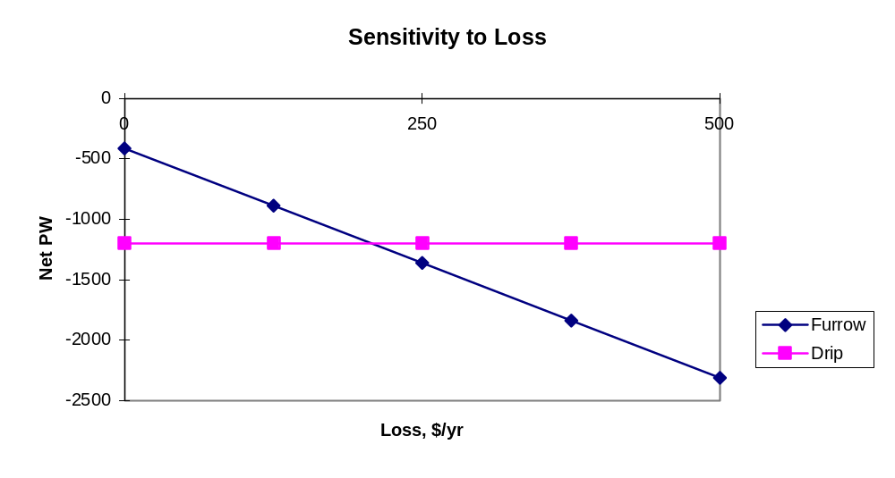
Conclude:
- the decision is sensitive to L_{f}
- very high maximum regret for Furrow: -1199 - (-2310) = $1111/acre
higher than that for Drip: - 415 - (-1199) = $784/acre

In some cases the decision may be sensitive, but if the maximum regret is low, the choice is not critical:

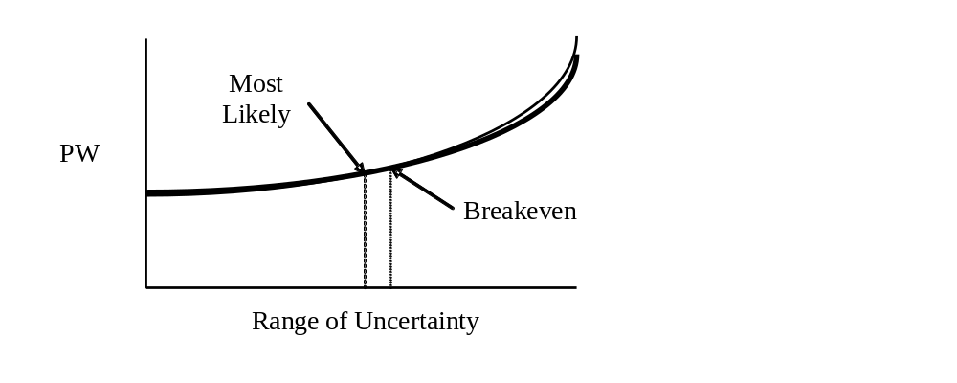
When the max regret for an alternative is small, the choice of that alternative is robust
because we won’t be too upset if, in hindsight, we chose the poorer alternative.

If the max regret is large, we may want to spend more money to collect better information and reduce the range of uncertainty. Sometimes this is possible, other times not.

